# SPRING BOOT

- Introduction to Spring Boot

What is Spring Boot?
Spring Boot is an open-source, Java-based framework used to create stand-alone, production-ready Spring applications with minimal configuration. Built on top of the Spring Framework, it simplifies bootstrapping and development by offering default settings and reducing boilerplate code.

Features of Spring Boot
- Auto-Configuration: Automatically configures your application based on the dependencies declared in the project.
- Standalone Applications: Enables creating applications that can run independently using embedded servers like Tomcat or Jetty.
- Production-Ready: Includes built-in features like metrics, health checks, and external configuration via Spring Boot Actuator.

- Opinionated Defaults: Reduces the need for manual configurations with pre-defined, best-practice defaults.
- No XML Configuration: Encourages convention over configuration using annotations instead of XML files.

Advantages of Using Spring Boot
- ✅ Rapid Application Development
- ✅ Auto-Configuration
- ✅ Embedded Web Servers
  - Supports Tomcat, Jetty, Undertow
  - Run applications using: java -jar app.jar
- ✅ Microservices-Friendly
- ✅ Production-Ready Features
  - Health checks, metrics, externalized config via Actuator
- ✅ Reduced Boilerplate Code
- ✅ Easy Dependency Management
- ✅ Seamless Integration with Spring Ecosystem
  - Compatible with Spring Data JPA, Spring Security,
Spring WebFlux, Spring Batch
- ✅ Flexible Configuration
  - Supports application.properties and
application.yml
- ✅ Community and Ecosystem Support

Use Cases

Spring Boot is used in a wide variety of domains:
- RESTful API development
- Microservices architecture
- Rapid prototyping
- Enterprise web applications
- Cloud-native applications

Real Life Examples:
- 🔹 E-Commerce Platforms
- 🔹 Banking & Financial Services
- 🔹 Healthcare Systems
- 🔹 Travel and Booking Platforms
- 🔹 Learning Management Systems (LMS)
- 🔹 Logistics & Supply Chain Systems
- 🔹 Content Management Systems (CMS)
- 🔹 HR & Payroll Systems
- 🔹 IoT Backend Services
- 🔹 Microservices in Large Enterprises

Language Support:
- ✅ Java (Primary Language)
- ✅ Kotlin
- ✅ Groovy
- ⚠ Scala (Limited Support)

Spring Boot vs Spring Framework

Key Differences

Feature / Aspect | Spring Framework | Spring Boot
Setup & Configuration | Manual XML/Java-based configuration | Auto-configuration, zero XML
Application Startup | Requires external servlet container | Comes with embedded servers (Tomcat, Jetty, Undertow)
Dependency Management | Developer-managed dependencies | Pre-configured starter dependencies
Boilerplate Code | More boilerplate and configuration | Minimal configuration and boilerplate
Project Structure | Developer decides from scratch | Convention over configuration
Production Readiness | Requires manual setup of monitoring tools | Built-in Actuator endpoints for health, metrics, etc.
Build Output | WAR (typically) | Executable JAR by default
Learning Curve | Steeper for beginners | Easier and quicker to get started
CLI Support | No | Yes, via Spring Boot CLI
Microservices Development | Needs custom setup | Tailored for microservices architecture

1.5 Spring Boot Architecture

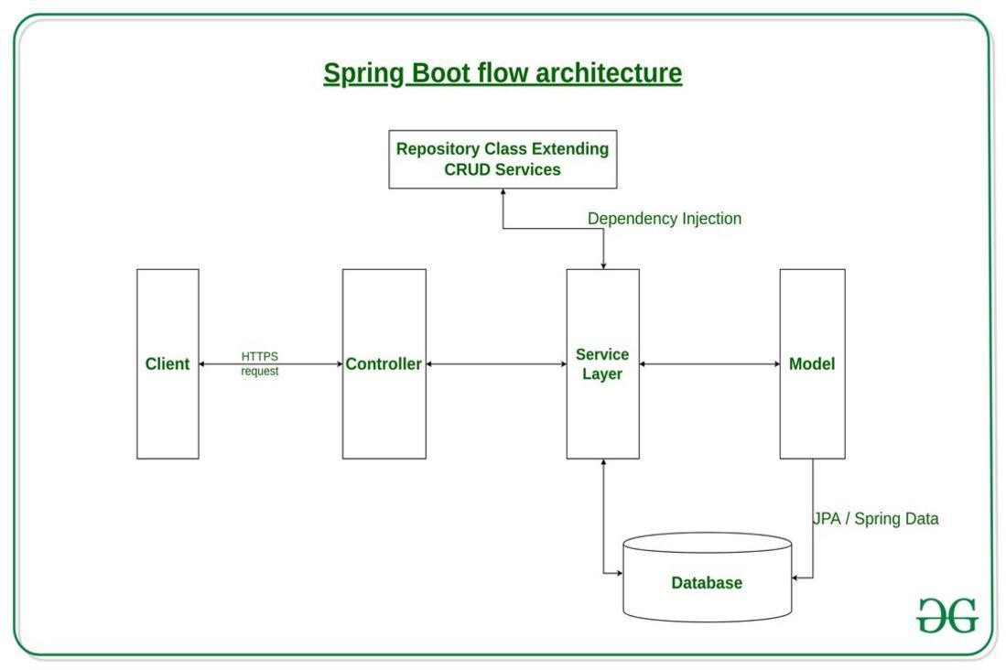

Spring Boot architecture is based on:

- Spring Core: Base dependency injection and AOP framework
- Auto Configuration: Automatically configures beans based on classpath
- Starter Dependencies: Predefined sets of dependencies for various features (web, data, etc.)
- Spring Boot CLI: Command-line tool to run and test applications
- Embedded Server: Tomcat, Jetty, or Undertow
- Spring Boot Actuator: Provides operational endpoints for monitoring and management

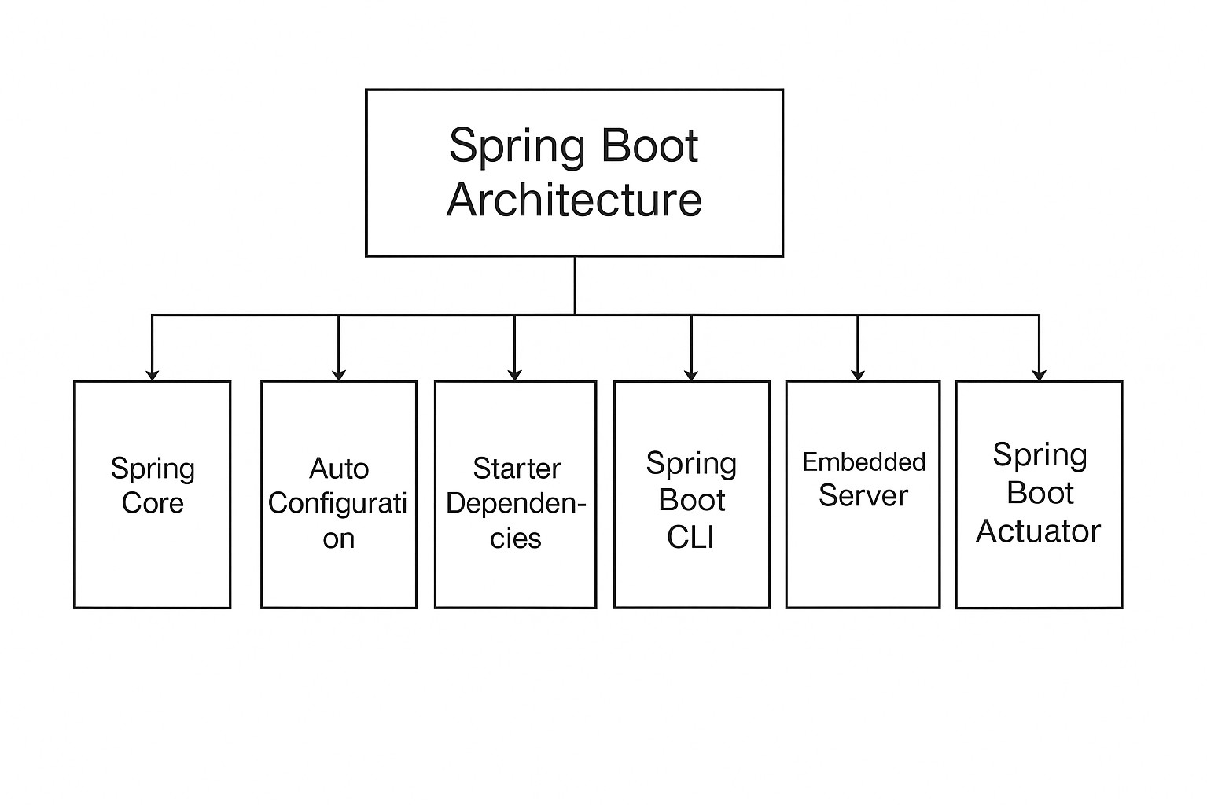

Topics Summary:
➢
- Introduction
  - What is Spring Boot?
  - Features of Spring Boot
  - Advantages and Use cases of using Spring Boot
  - Spring Boot vs Spring Framework
  - Spring Boot Architecture

- 2. Getting Started
  - Setting up Spring Boot Project (Spring Initializr, Maven, Gradle)
  - Project Structure Overview
  - Application Entry Point (@SpringBootApplication)
  - Running the Application

- 3. Core Concepts
  - Spring Boot Annotations
    - @SpringBootApplication
    - @Component, @Service, @Repository, @Controller, @RestController
    - @Autowired, @Qualifier

    - @Configuration, @Bean
  - Dependency Injection (DI)
  - Inversion of Control (IoC)

- 4. Configuration
  - application.properties vs application.yml
  - External Configuration (env vars, CLI args)
  - Profiles (@Profile)
  - Property Injection: @Value, @ConfigurationProperties

- 5. Spring Boot Starters
  - What are Starters?
  - Common Starters
    - spring-boot-starter-web
    - spring-boot-starter-data-jpa
    - spring-boot-starter-security
    - spring-boot-starter-test, etc.

- 6. Web Development (Spring MVC)
  - Creating REST APIs (@RestController)
  - Handling Request Parameters
@PathVariable, @RequestParam, @RequestBody
  - ResponseEntity and Status Codes
  - Exception Handling
@ControllerAdvice, @ExceptionHandler
  - Content Negotiation

- 7. Data Access
  - Spring Data JPA
    - Entity Classes (@Entity)
    - Repositories (JpaRepository, CrudRepository)
    - Custom Queries (@Query)
    - Pagination and Sorting
  - JDBC with Spring Boot
  - MongoDB / NoSQL
  - Transactions (@Transactional)

- 8. Database Configuration
  - H2 In-Memory Database
  - MySQL/PostgreSQL setup
  - Connection Pooling (HikariCP)

  - Schema Initialization (schema.sql, data.sql)

- 9. Validation
  - Bean Validation (javax.validation)
  - Using @Valid, @Validated
  - Custom Validators

- 10. Security
  - Spring Security Basics
  - Authentication and Authorization
  - Password Encoding
  - JWT Token-based Security
  - Role-Based Access Control

- 11. Testing
  - Unit Testing with JUnit
  - Mocking with Mockito
  - Integration Testing
  - Web Layer Testing (@WebMvcTest)
  - Data Layer Testing (@DataJpaTest)

- 12. Logging
  - SLF4J and Logback
  - Configuring Log Levels
  - External Log Configuration

- 13. Actuator & Monitoring
  - Spring Boot Actuator Overview
  - Common Actuator Endpoints
  - Custom Metrics
  - Prometheus/Grafana Integration

- 14. Error Handling
  - Default Error Handling
  - Custom Error Pages
  - Global Exception Handling

- 15. Developer Tools
  - Spring Boot DevTools
  - Auto Restart
  - Live Reload

- 16. Caching
  - Using @Cacheable, @CacheEvict
  - Cache Providers (Ehcache, Caffeine, Redis)

- 17. Scheduling & Async
  - Scheduling Tasks (@Scheduled)
  - Asynchronous Execution (@Async)

- 18. Messaging
  - RabbitMQ
  - Kafka
  - JMS Integration

- 19. File Upload/Download
  - Multipart File Upload
  - File Storage and Download Handling

- 20. Frontend Integration
  - Serving Static Files
  - Using Thymeleaf
  - Enabling CORS

- 21. Build & Deployment
  - Building JAR/WAR
  - Dockerizing Spring Boot Application
  - Deploying to Cloud (AWS, Azure, GCP)
  - CI/CD Integration

- 22. Advanced Topics
  - Microservices with Spring Boot
    - Spring Cloud
    - Eureka (Service Discovery)
    - Spring Cloud Gateway / Zuul
    - Circuit Breaker (Resilience4j, Hystrix)
    - Config Server
  - ApplicationEventPublisher & Event Listeners
  - Creating Custom Starters

Getting Started

Setting up Spring Boot Project (Spring Initializr, Maven, Gradle)
https://start.spring.io/
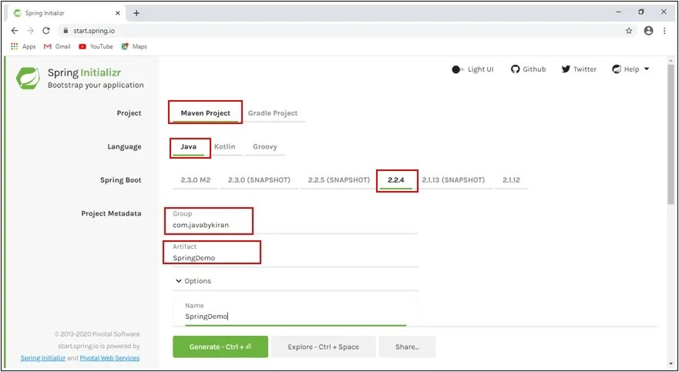

  - Project Structure Overview

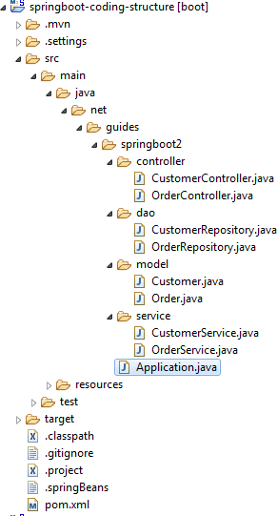

  - Application Entry Point (@SpringBootApplication)

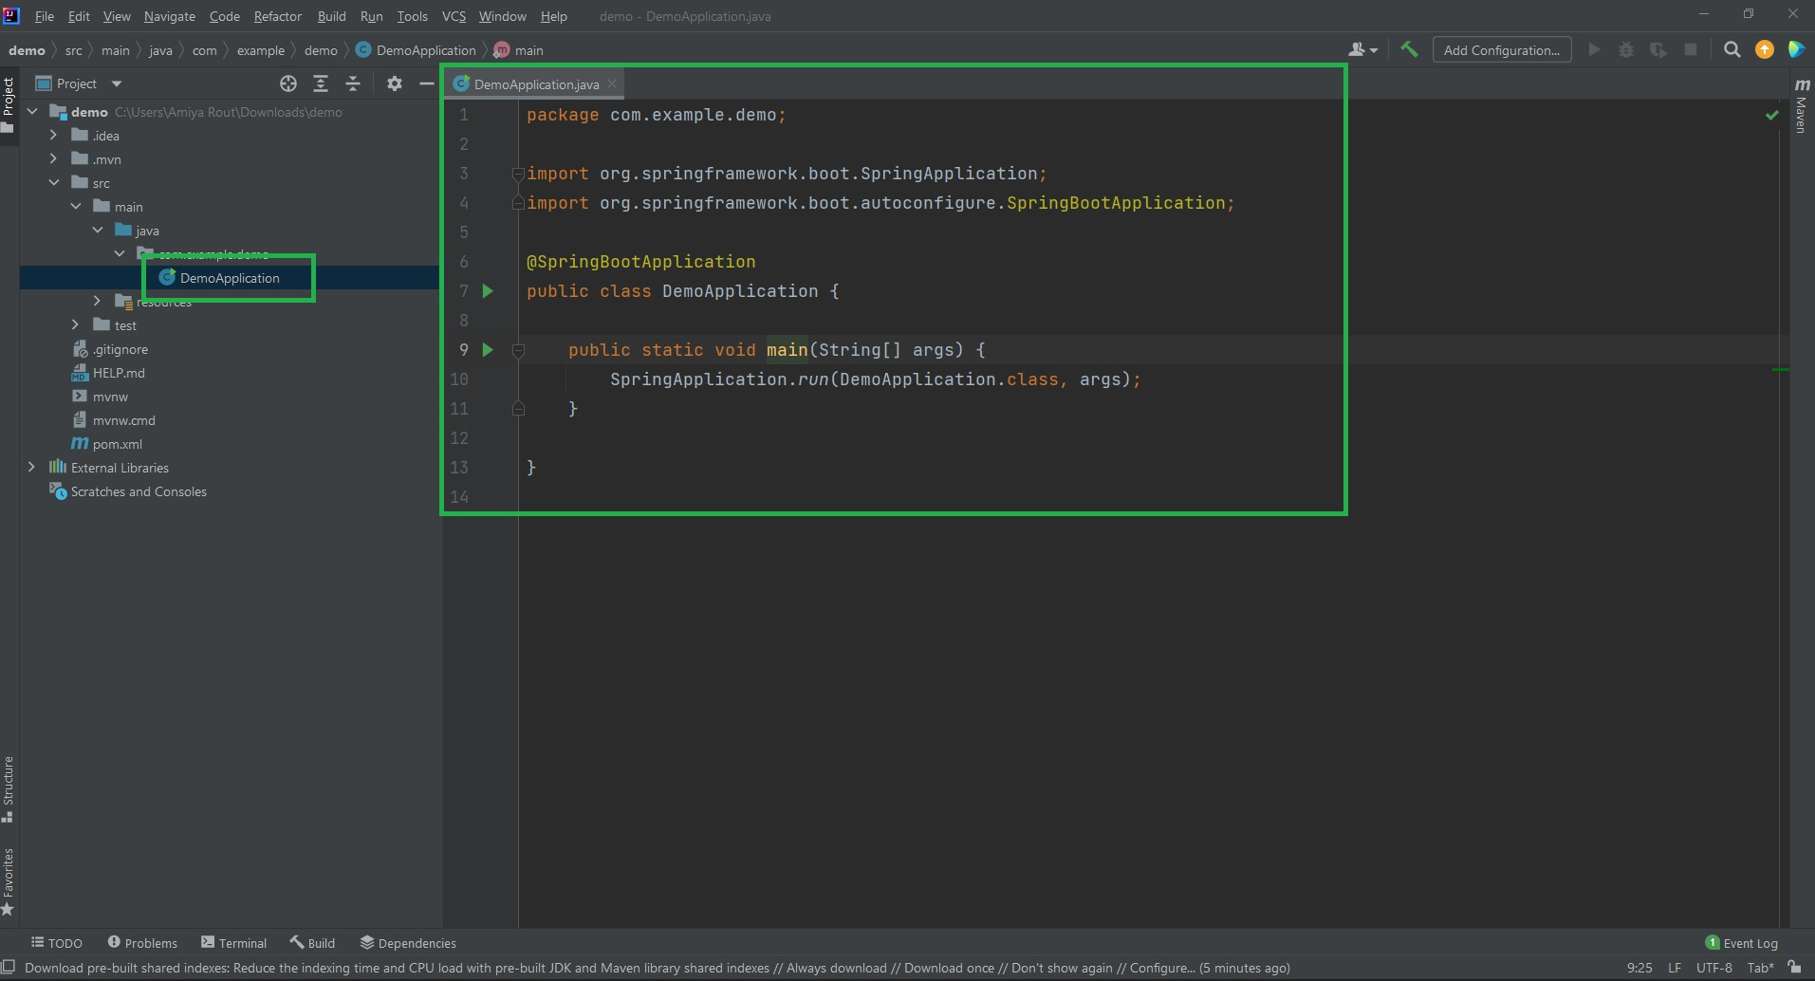

  - Running the Application

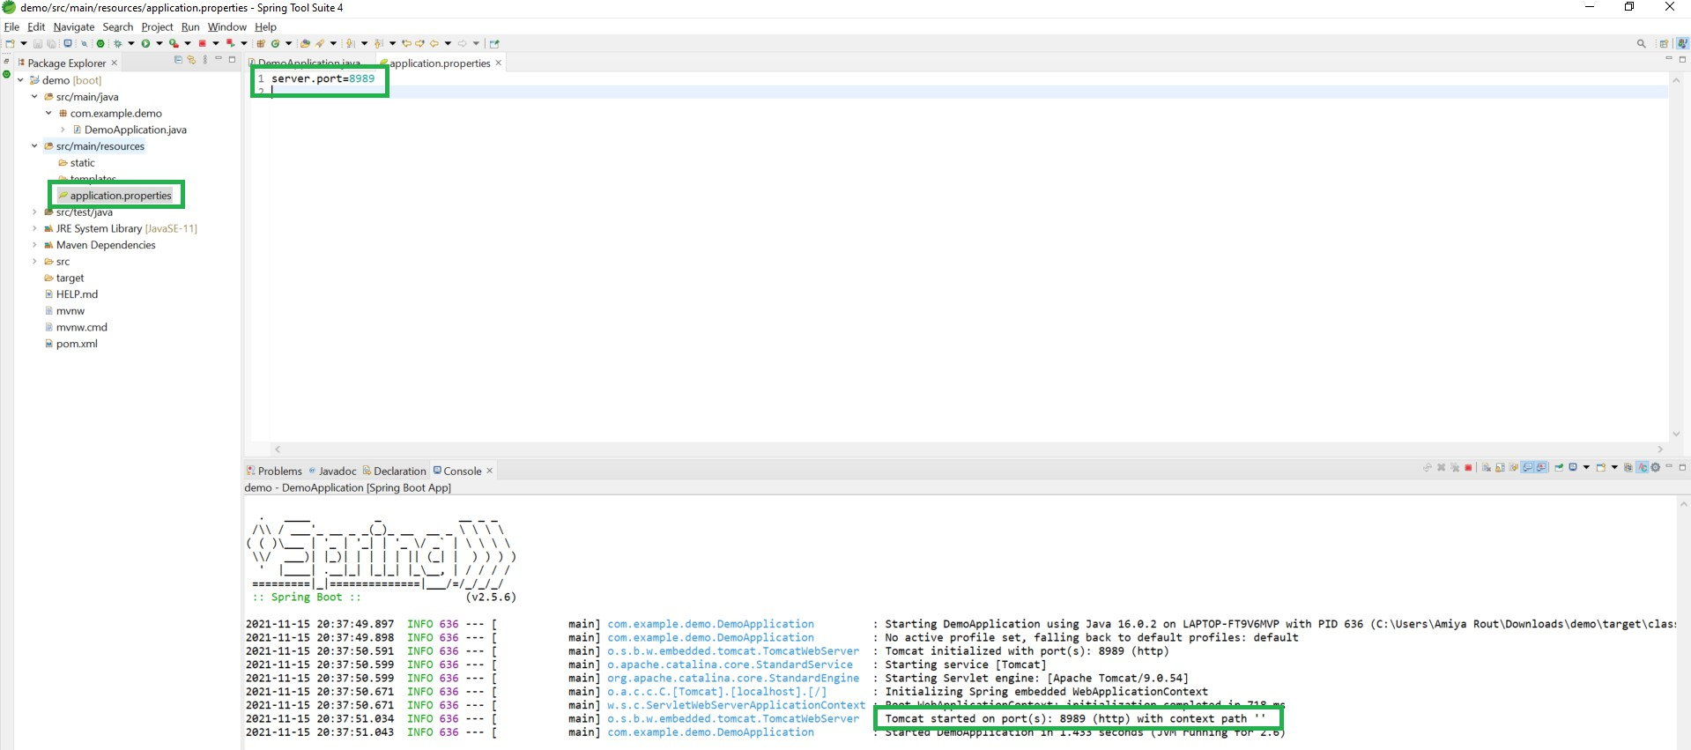

Core Concepts

Spring Boot Annotations

    - @SpringBootApplication

The @SpringBootApplication annotation is the primary entry point of any Spring Boot application. It is a convenience annotation that combines three commonly used annotations in Spring:
@SpringBootApplication = @Configuration + @EnableAutoConfiguration + @ComponentScan

Declaration @SpringBootApplication public class MyApplication {
public static void main(String[] args) { SpringApplication.run(MyApplication.class, args);
}

}

    - @Component, @Service, @Repository, @Controller, @RestController

@Component
Definition

@Component is a generic stereotype annotation that marks a class as a Spring-managed component.

@Component

public class MyComponent {

// Business logic

}

Use Case

Used when the class doesn't clearly fall into service, repository, or controller layers.

@Service
Definition

@Service is a specialization of @Component used to annotate service layer classes that contain business logic.
@Service

public class OrderService {

public void processOrder() {

// Business logic

}

}

Use Case

- Encapsulates business logic

- Makes the code more readable and structured

- Can integrate with AOP (for transaction, logging, etc.)

@Repository
Definition

@Repository is a specialization of @Component used for DAO (Data Access Object)
classes. It also provides exception translation for database errors.

@Repository

public class ProductRepository {

public void save(Product product) {

// Save to DB

}

}

Use Case

- Used for data persistence

- Automatically translates exceptions to Spring’s DataAccessException

@Controller
Definition

@Controller is used to define web layer classes in Spring MVC. It is used for rendering
views (HTML) with model data. @Controller
public class HomeController { @GetMapping("/")
public String index(Model model) { model.addAttribute("message", "Welcome"); return "index"; // returns view name
}

}

Use Case

Used when working with traditional web applications (Thymeleaf, JSP, etc.)

@RestController

Definition

@RestController = @Controller + @ResponseBody
Used to define RESTful web services. The return values are serialized as JSON or XML and sent directly to the client.
@RestController

public class UserController { @GetMapping("/users")
public List<User> getAllUsers() { return userService.getAll();
}

}

Use Case

- Used in REST APIs

- Automatically serializes Java objects to JSON

Summary Table

Annotation | Layer | Inherits From | Purpose | Returns Response Body
@Component | Generic | - | General-purpose component | No
@Service | Service Layer | @Component | Business logic and services | No
@Repository | Data Layer | @Component | DAO & exception translation | No

@Controller | Web (MVC) | @Component | Handles web requests & returns views | No (uses View Resolver)
@RestControl ler | Web (REST API) | @Controlle r | Returns JSON/XML directly to the client | Yes

    - @Autowired, @Qualifier
@Autowired is used to automatically wire dependencies.

@Qualifier is used to resolve conflicts when multiple beans of the same type are available.

@Autowired

Definition

@Autowired is used to automatically inject a bean from the Spring container into another bean by type.
@Component

public class CarService {

@Autowired

private Engine engine;

// engine will be injected automatically

}

Where It Can Be Used

- On fields

- On constructors

- On setter methods

Example (Constructor Injection)

@Service

public class OrderService {

private final PaymentService paymentService;

@Autowired

public OrderService(PaymentService paymentService) { this.paymentService = paymentService;
}

}

@Qualifier

Definition

@Qualifier is used with @Autowired to specify which bean to inject
when multiple candidates of the same type are available. @Component("dieselEngine")
public class DieselEngine implements Engine { }

@Component("petrolEngine")

public class PetrolEngine implements Engine { }

@Service

public class CarService {

@Autowired @Qualifier("dieselEngine") private Engine engine;
}

Use Case

- Disambiguating among multiple beans of the same type.

- Explicitly specifying the bean to be injected.

    - @Configuration, @Bean

@Configuration

Definition

@Configuration is a class-level annotation that indicates the class contains bean definitions for the Spring IoC container. It serves as a replacement for XML-based configuration.
@Configuration

public class AppConfig {

// Bean definitions go here

}

@Configuration

public class AppConfig {

// Bean definitions go here

}

@Bean

Definition

@Bean is a method-level annotation used inside a @Configuration-annotated class to define a bean explicitly.
@Bean

public DataSource dataSource() { return new HikariDataSource();
}

@Configuration

public class AppConfig {

@Bean

public UserService userService() {

return new UserServiceImpl(userRepository());

}

@Bean

public UserRepository userRepository() { return new InMemoryUserRepository();
}

}

Dependency Injection (DI)

Dependency Injection is a programming technique where an object receives its dependencies from an external source rather than creating them internally.

Why Use Dependency Injection?
- Promotes loose coupling between classes

- Improves testability and maintainability

- Encourages modular and reusable code

- Follows SOLID principles (especially the "D" — Dependency Inversion Principle)

Types of Dependency Injection in Spring

Type | Description | Syntax Example
Constructor Injection | Dependencies are passed through a constructor. | Preferred for mandatory dependencies

Setter Injection | Dependencies are set via setter methods. | Suitable for optional dependencies
Field Injection | Dependencies are injected directly into fields using @Autowired. | Quick but less recommended for testing

Example: Constructor Injection @Service
public class OrderService {

private final PaymentService paymentService;

@Autowired

public OrderService(PaymentService paymentService) { this.paymentService = paymentService;
}

public void placeOrder() { paymentService.processPayment();
}

}

Here:

- OrderService depends on PaymentService.

- The Spring container injects PaymentService at runtime.

Dependency Injection vs. Manual Instantiation

Manual Instantiation | With Spring DI
PaymentService ps = new PaymentService(); | @Autowired PaymentService paymentService;
Tightly coupled code | Loosely coupled, easily testable

Spring Annotations for DI

Annotation | Purpose
@Autowired | Marks a dependency to be injected by Spring
@Qualifier | Resolves ambiguity when multiple beans of same type
@Inject (JSR-330) | Java standard equivalent of @Autowired
@Value | Injects values from properties or expressions

Benefits of Using DI in Spring Boot
- ✅ Loose Coupling: Classes are not tightly bound to specific implementations.
- ✅ Testability: Easier to write unit tests by injecting mock dependencies.

- ✅ Readability: Clearly defines class dependencies.
- ✅ Maintainability: Changes to one class do not affect dependent classes directly.

Inversion of Control (IoC)

Inversion of Control (IoC) is a design principle in which the control of object creation and dependency resolution is transferred from the program (developer) to a framework or container.

How IoC Works in Spring
    - The developer defines application components (beans) using annotations or configuration.

    - Spring's IoC container:

      - Scans the classpath.

      - Detects annotated components.

      - Creates and wires dependencies automatically.

    - The container manages the entire lifecycle of those objects.

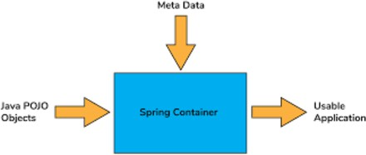
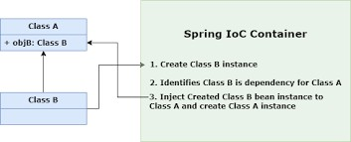
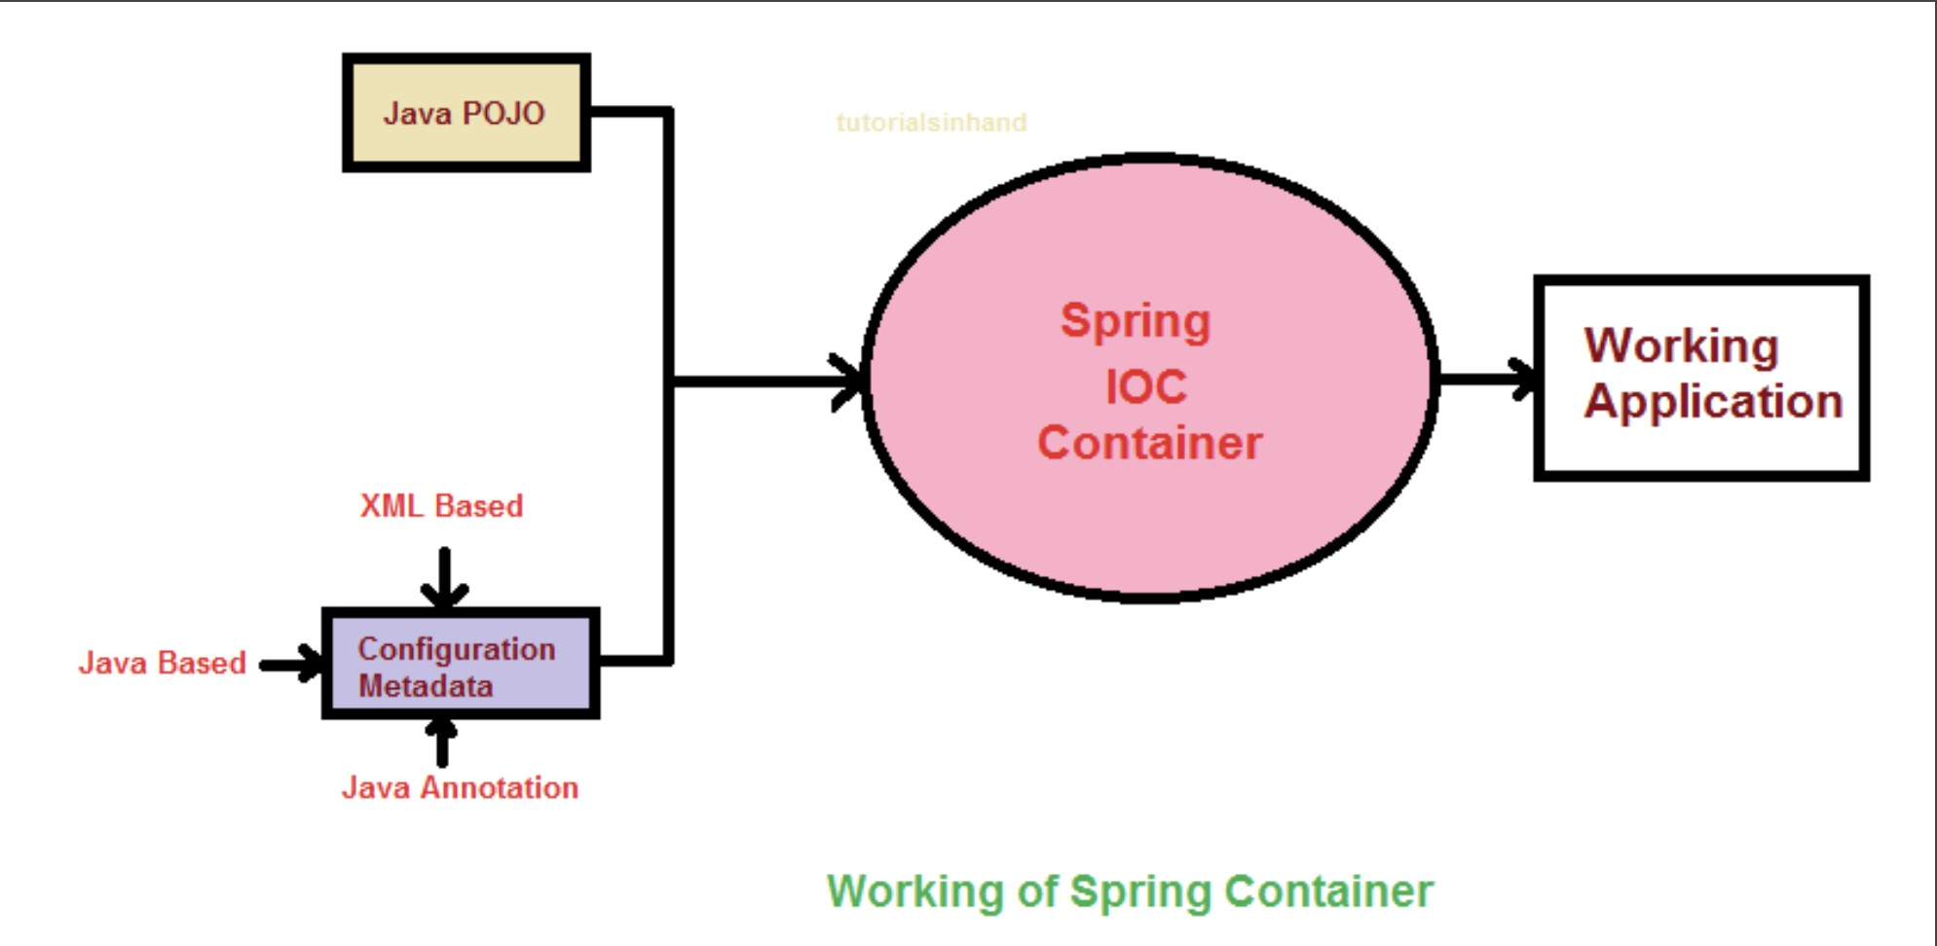

Configuration

Overview

Configuration is a core aspect of Spring Boot that enables you to customize application behavior without changing the source code. Spring Boot provides multiple ways to configure applications, including property files, YAML files, environment variables, command-line arguments, and more.
This section explores key configuration concepts:

- application.properties vs application.yml

- External configuration sources

- Profiles for environment-specific settings

- Property injection using @Value and @ConfigurationProperties

application.properties vs application.yml

Spring Boot supports two main configuration file formats:

Feature | application.properties | application.yml

Format | Key-value pairs | Hierarchical, indentation-based
Readability for complex configs | Less readable for nested values | More readable for nested/grouped configs
Syntax | key=value | YAML syntax using indentation

Example: application.properties

server.port=8081 spring.datasource.url=jdbc:mysql://localhost:3306/db spring.datasource.username=root spring.datasource.password=pass

Example: application.yml

server: port: 8081
spring: datasource:
url: jdbc:mysql://localhost:3306/db username: root
password: pass

External Configuration

Spring Boot allows external configuration via:

Source | Priority (High → Low)
Command-line arguments | ✅ Highest priority
Environment variables | ✅ OS/environment-specific configs
application.properties/ yml | ✅ Default file-based config
Profile-specific files | ✅ Based on environment

Example: Using Environment Variables

export SPRING_DATASOURCE_URL=jdbc:mysql://localhost:3306/db Spring automatically maps it to spring.datasource.url.

Example: Using Command-line Arguments
java -jar myapp.jar --server.port=9090 --logging.level.root=DEBUG

These override values from config files.

Profiles (@Profile)

Spring Profiles allow you to define environment-specific configurations (e.g., dev, test, prod).

How to Use Profiles
- Create profile-specific property files:

  - application-dev.properties

  - application-prod.yml

- Activate profile using:

  - Application.properties: spring.profiles.active=dev
  - Or via CLI:

java -jar app.jar --spring.profiles.active=prod Example: Conditional Bean with @Profile @Configuration
@Profile("dev")

public class DevConfig { @Bean
public String dataSource() { return "H2 In-Memory DB for Dev";
}

}

@Configuration @Profile("prod")
public class ProdConfig { @Bean
public String dataSource() { return "MySQL DB for Production";
}

}

Property Injection: @Value vs @ConfigurationProperties

Spring provides two ways to inject properties into Java classes.

@Value Annotation

  - Injects individual values from properties or YAML files.

  - Lightweight and direct.

@Component

public class AppSettings {

@Value("${server.port}") private int port;

@Value("${custom.message:Default Message}") private String message; // Fallback value if not defined
}

@ConfigurationProperties Annotation
  - Maps a group of related properties into a POJO.

  - Cleaner for structured configs.

YAML Example

app:

name: MyApp version: 1.0

@Component @ConfigurationProperties(prefix = "app") public class AppProperties {
private String name; private String version;

// Getters and Setters

}

Enable Binding (if not using @SpringBootApplication)

@EnableConfigurationProperties(AppProperties.class)

Comparison Table

Feature | @Value | @ConfigurationProperties
Purpose | Inject individual values | Bind multiple related properties
Use Case | Simple property access | Structured/grouped configuration
Validation Support | Limited | Strong (with JSR-303 annotations)
Default Value Support | Yes (@Value("${key:default}"  )) | No (use validation instead)

Spring Boot Starters

What are Starters?
A Starter is a pre-defined set of dependencies bundled under a single starter module, designed to support specific application needs (e.g., web, JPA, security).

Key Benefits
- Simplifies Maven/Gradle configuration

- Reduces boilerplate dependency management

- Ensures compatible versions for Spring Boot

Example pom.xml
<!-- Instead of specifying multiple web libraries manually -->

<dependency>

<groupId>org.springframework.boot</groupId>

<artifactId>spring-boot-starter-web</artifactId>

</dependency>

Common Starters
Below are the most frequently used Spring Boot starters:

spring-boot-starter-web
Used to build web applications and RESTful services using Spring MVC.

Includes:

      - Spring MVC

      - Jackson (for JSON binding)

      - Embedded Tomcat (by default)

Example Use Case:

@RestController

public class HelloController { @GetMapping("/hello") public String greet() {

return "Hello, World!";

}

}

spring-boot-starter-data-jpa
Used to enable Spring Data JPA for data access with relational databases.

Includes:

      - Spring Data JPA

      - Hibernate

      - Spring ORM

Example Use Case:

@Entity

public class User {

@Id @GeneratedValue private Long id;
private String name;

}

public interface UserRepository extends JpaRepository<User, Long> {}

spring-boot-starter-security
Used to add authentication and authorization to your application.

Includes:

      - Spring Security

Example Use Case:

Secures all endpoints by default. You can configure custom login: @Configuration
public class SecurityConfig extends WebSecurityConfigurerAdapter { @Override
protected void configure(HttpSecurity http) throws Exception { http.authorizeRequests()
.anyRequest().authenticated()

.and().formLogin();

}

}

spring-boot-starter-test
Used to write unit and integration tests. Includes:
      - JUnit 5

      - Mockito

      - Spring Test

      - AssertJ

Example Use Case:

@SpringBootTest

public class MyServiceTest {

@Autowired

private MyService myService;

@Test

void testLogic() {

assertEquals("expected", myService.doSomething());

}

}

Other Useful Starters

Starter | Purpose
spring-boot-starter-thym eleaf | HTML template rendering
spring-boot-starter-mail | Sending emails
spring-boot-starter-actu ator | Monitoring and managing applications
spring-boot-starter-vali dation | Bean validation using Hibernate Validator

Web Development with Spring Boot (Spring MVC)

Overview
Spring Boot supports full-stack web development using Spring MVC, allowing you to build RESTful APIs and web applications easily. This section covers core web development concepts such as REST controllers, request handling, exception management, and content negotiation.

Creating REST APIs (@RestController)
@RestController combines @Controller and @ResponseBody, enabling RESTful endpoints.

Example

@RestController @RequestMapping("/api/users") public class UserController {

@GetMapping("/{id}")
public User getUser(@PathVariable Long id) { return new User(id, "John Doe");
}
}

Handling Request Parameters

@PathVariable, @RequestParam, @RequestBody

Annotation | Description | Example Usage
@PathVariab le | Binds a URL segment to a method parameter | /users/{id} → @PathVariable Long id
@RequestPar am | Extracts query parameters from the URL | /users?role=admin →  @RequestParam String role
@RequestBod y | Binds request JSON/XML body to an object | JSON POST → @RequestBody User user

@PostMapping("/create")
public ResponseEntity<String> createUser(@RequestBody User user) { return ResponseEntity.ok("User created: " + user.getName());
}

@GetMapping("/find")
public String findUser(@RequestParam String role) { return "Finding user with role: " + role;
}

ResponseEntity and Status Codes
ResponseEntity allows customizing the response body, headers, and HTTP status.

Example
@GetMapping("/{id}")
public ResponseEntity<User> getUser(@PathVariable Long id) { User user = userService.findById(id);
if (user == null) {
return ResponseEntity.status(HttpStatus.NOT_FOUND).build();
}
return ResponseEntity.ok(user);
}

Exception Handling

@ControllerAdvice and @ExceptionHandler

Global exception handling using @ControllerAdvice and specific error response logic using
@ExceptionHandler.

Example

@ControllerAdvice
public class GlobalExceptionHandler {

@ExceptionHandler(UserNotFoundException.class)
public ResponseEntity<String> handleUserNotFound(UserNotFoundException ex) { return ResponseEntity.status(HttpStatus.NOT_FOUND).body(ex.getMessage());
}
}

Content Negotiation

Spring automatically supports content negotiation, allowing responses in different formats (e.g., JSON, XML) based on Accept headers.

Example
@GetMapping(value = "/info", produces = { MediaType.APPLICATION_JSON_VALUE, MediaType.APPLICATION_XML_VALUE })
public User getInfo() {
return new User(1L, "Alice");
}

- Request Accept: application/json → JSON

- Request Accept: application/xml → XML

Data Access in Spring Boot

Overview

Spring Boot simplifies data access by providing integration with various data sources like relational databases (via JPA and JDBC) and NoSQL databases (e.g., MongoDB). It also supports robust transaction management.

Spring Data JPA
Spring Data JPA abstracts data access layers by providing ready-to-use repositories and powerful query capabilities.

Entity Classes (@Entity)

@Entity marks a Java class as a table in the database.

Example

@Entity

public class User {

@Id @GeneratedValue private Long id;
private String name;

}

Repositories (JpaRepository, CrudRepository)
Spring Data provides interfaces for CRUD operations without boilerplate code.

Example

public interface UserRepository extends JpaRepository<User, Long> { List<User> findByName(String name);
}

Custom Queries (@Query)
Define complex queries using JPQL or native SQL.

Example

@Query("SELECT u FROM User u WHERE u.name LIKE %:name%") List<User> searchByName(@Param("name") String name);

Pagination and Sorting

Built-in support via Pageable and Sort.

Example

Page<User> page = userRepository.findAll(PageRequest.of(0, 10, Sort.by("name")));

JDBC with Spring Boot
Use JdbcTemplate for fine-grained SQL operations.

Example

@Repository

public class UserDao {

@Autowired

private JdbcTemplate jdbcTemplate;

public List<User> getUsers() {

return jdbcTemplate.query("SELECT * FROM users",

(rs, rowNum) -> new User(rs.getLong("id"), rs.getString("name")));

}

}

MongoDB / NoSQL
Spring Boot provides spring-boot-starter-data-mongodb for integrating MongoDB.

Example

@Document

public class Product {

@Id

private String id; private String name;
}

public interface ProductRepository extends MongoRepository<Product, String> { List<Product> findByName(String name);
}

<dependency>

<groupId>org.springframework.boot</groupId>

<artifactId>spring-boot-starter-data-mongodb</artifactId>

</dependency>

Transactions (@Transactional)
Ensures atomicity for multiple database operations.

Example

@Service

public class UserService {

@Autowired

private UserRepository userRepository;

@Transactional

public void registerUser(User user) { userRepository.save(user);
// Additional DB operations

}

}

You can also use @Transactional(readOnly = true) for read operations.

Database Configuration in Spring Boot

Overview
Spring Boot offers seamless integration with relational databases such as H2, MySQL, PostgreSQL, and supports configuration for connection pooling and schema initialization through simple properties or SQL files.

H2 In-Memory Database
The H2 database is an in-memory relational database ideal for development and testing. It runs in memory and is destroyed when the application stops.

Add Dependency
<dependency>

<groupId>com.h2database</groupId>

<artifactId>h2</artifactId>

<scope>runtime</scope>

</dependency>

Configure (application.properties) spring.datasource.url=jdbc:h2:mem:testdb spring.datasource.driver-class-name=org.h2.Driver spring.datasource.username=sa spring.datasource.password= spring.h2.console.enabled=true

H2 Console

Access the console at: http://localhost:8080/h2-console
Driver Class: org.h2.Driver
JDBC URL: jdbc:h2:mem:testdb

MySQL / PostgreSQL Setup

MySQL Example Configuration
<!-- Add MySQL dependency -->

<dependency>

<groupId>mysql</groupId>

<artifactId>mysql-connector-j</artifactId>

<scope>runtime</scope>

</dependency>

# application.properties spring.datasource.url=jdbc:mysql://localhost:3306/mydb spring.datasource.username=root spring.datasource.password=your_password spring.jpa.hibernate.ddl-auto=update
spring.jpa.show-sql=true

PostgreSQL Configuration

<dependency>

<groupId>org.postgresql</groupId>

<artifactId>postgresql</artifactId>

<scope>runtime</scope>

</dependency>

spring.datasource.url=jdbc:postgresql://localhost:5432/mydb spring.datasource.username=postgres spring.datasource.password=your_password

Connection Pooling (HikariCP)
Spring Boot uses HikariCP as the default connection pool for better performance.

Default Settings (optional to override) spring.datasource.hikari.maximum-pool-size=10 spring.datasource.hikari.minimum-idle=5
spring.datasource.hikari.idle-timeout=30000 spring.datasource.hikari.pool-name=SpringBootHikariCP

Schema Initialization (schema.sql, data.sql)
Spring Boot executes these SQL files automatically on startup to initialize the database.

Usage

Place these files in src/main/resources/:

- schema.sql → For creating tables

- data.sql → For inserting initial data

Example: schema.sql

CREATE TABLE users (

id BIGINT PRIMARY KEY AUTO_INCREMENT, name VARCHAR(100)
);

Example: data.sql

INSERT INTO users (name) VALUES ('John Doe'), ('Alice');

Validation in Spring Boot

Overview
Spring Boot supports bean validation using JSR-380 (Jakarta Bean Validation / javax.validation). It allows automatic input validation for REST APIs and form data using annotations like @NotNull, @Email, and more. Validation can be enhanced using @Valid, @Validated, and custom validators.

Bean Validation (javax.validation)
Spring Boot auto-configures bean validation when spring-boot-starter-validation is on the classpath.

Add Dependency (if needed)
<dependency>

<groupId>org.springframework.boot</groupId>

<artifactId>spring-boot-starter-validation</artifactId>

</dependency>

Common Validation Annotations

Annotation | Description
@NotNull | Field must not be null

@NotBlank | Field must not be null or empty
@Email | Must be a valid email address
@Size(min, max) | String/collection size constraints
@Min, @Max | Numeric value limits

Example

public class User {

@NotBlank

private String name;

@Email

private String email;

@Min(18) private int age;

// Getters & Setters

}

Using @Valid and @Validated

@Valid
Used to trigger validation on a method parameter (commonly in controllers). @RestController
@RequestMapping("/users") public class UserController {

@PostMapping

public ResponseEntity<String> addUser(@Valid @RequestBody User user) { return ResponseEntity.ok("User is valid");
}

}

Spring will automatically return a 400 Bad Request if validation fails, along with error messages.

@Validated
Used on a class to validate method-level constraints or with groups for conditional validation.
@Validated @Service
public class PaymentService {

public void process(@Min(100) int amount) {

// Only processes if amount >= 100

}

}

Custom Validators
You can create custom constraints using @Constraint.

Steps to Create a Custom Validator
- Define the annotation: @Constraint(validatedBy = UsernameValidator.class) @Target({ FIELD })
@Retention(RUNTIME)

public @interface ValidUsername {

String message() default "Invalid username"; Class<?>[] groups() default {};
Class<? extends Payload>[] payload() default {};

}

- Create the validator class:

public class UsernameValidator implements ConstraintValidator<ValidUsername, String>
{

@Override

public boolean isValid(String value, ConstraintValidatorContext context) { return value != null && value.matches("^[a-zA-Z0-9_]{5,20}$");

}

}

- Use the annotation:

public class User {

@ValidUsername

private String username;

}

Security in Spring Boot

Overview
Spring Boot integrates Spring Security, a powerful and customizable authentication and access-control framework. It provides robust security for web applications, REST APIs, and microservices.

Spring Security Basics
To enable security in Spring Boot, include the starter dependency:

Dependency
<dependency>

<groupId>org.springframework.boot</groupId>

<artifactId>spring-boot-starter-security</artifactId>

</dependency>

By default, Spring Security:

- Secures all endpoints

- Provides a default login form

- Uses an auto-generated password (logged at startup)

Authentication and Authorization
Authentication identifies who the user is. Authorization defines what the user is allowed to do.

Basic Configuration Example @Configuration @EnableWebSecurity
public class SecurityConfig {

@Bean

public SecurityFilterChain securityFilterChain(HttpSecurity http) throws Exception { http
.authorizeHttpRequests(auth -> auth

.requestMatchers("/admin/**").hasRole("ADMIN")

.requestMatchers("/user/**").hasAnyRole("USER", "ADMIN")

.anyRequest().authenticated()

)

.httpBasic(); // For simple authentication return http.build();

}

@Bean
public InMemoryUserDetailsManager userDetailsService() { UserDetails user =
User.withUsername("user").password("{noop}1234").roles("USER").build();

UserDetails admin = User.withUsername("admin").password("{noop}admin123").roles("ADMIN").build();
return new InMemoryUserDetailsManager(user, admin);

}

}

Password Encoding
Use PasswordEncoder to store hashed passwords securely.

Example using BCrypt
@Bean

public PasswordEncoder passwordEncoder() { return new BCryptPasswordEncoder();
}

String encoded = passwordEncoder.encode("mypassword"); Always use encoded passwords (e.g., in DB) instead of plain text.

JWT Token-based Security
JWT (JSON Web Tokens) are widely used for securing REST APIs in stateless systems.

JWT Flow
- User sends credentials → gets a JWT

- Client sends JWT with requests

- Server validates the JWT

Example Controller to Issue JWT
@RestController

public class AuthController {

@PostMapping("/login")

public String login(@RequestBody AuthRequest request) {

// Authenticate and generate JWT

return jwtService.generateToken(request.getUsername());

}

}

JWT Filter (Simplified)

public class JwtFilter extends OncePerRequestFilter {

protected void doFilterInternal(HttpServletRequest request, HttpServletResponse response, FilterChain chain) {
String token = request.getHeader("Authorization");

// validate token and set authentication

chain.doFilter(request, response);

}

}

You must register the filter in the security chain.

Role-Based Access Control (RBAC)
Spring Security allows controlling access to resources by roles or authorities.

Example @GetMapping("/admin/dashboard") @PreAuthorize("hasRole('ADMIN')") public String adminDashboard() {
return "Admin area";

}

Enable Method-Level Security @EnableMethodSecurity
public class MethodSecurityConfig {

}

Testing in Spring Boot

Overview

Spring Boot provides first-class support for testing through JUnit, Mockito, and Spring TestContext Framework. It enables testing of individual components (unit tests), interactions (mocking), and full application context (integration testing).

Unit Testing with JUnit
JUnit is the standard framework for writing unit tests in Java.

Dependency
<dependency>

<groupId>org.springframework.boot</groupId>

<artifactId>spring-boot-starter-test</artifactId>

<scope>test</scope>

</dependency>

Example

class CalculatorService { int add(int a, int b) { return a + b;
}

}

class CalculatorServiceTest {

@Test

void testAdd() {

CalculatorService calc = new CalculatorService();

assertEquals(5, calc.add(2, 3));

}

}

Mocking with Mockito
Mockito is used to mock dependencies for isolated unit tests.

Example
@Service

class OrderService {

@Autowired private PaymentService paymentService;

public boolean placeOrder() { return paymentService.pay();
}

}

class OrderServiceTest {

@Mock PaymentService paymentService;

@InjectMocks OrderService orderService;

@BeforeEach

void init() { MockitoAnnotations.openMocks(this);
}

@Test

void testPlaceOrder() { when(paymentService.pay()).thenReturn(true); assertTrue(orderService.placeOrder());
}

}

Integration Testing
Integration tests load the full application context to test real behavior of beans.

Example
@SpringBootTest

class UserServiceIntegrationTest {

@Autowired UserService userService;

@Test

void testFindUser() {

User user = userService.findById(1L); assertNotNull(user);

}

}

Web Layer Testing (@WebMvcTest)
Used to test only the web layer (controllers) without loading the full context.

Example @WebMvcTest(UserController.class) class UserControllerTest {

@Autowired private MockMvc mockMvc;

@Test

void testGetUser() throws Exception { mockMvc.perform(get("/users/1"))
.andExpect(status().isOk());

}

}

It auto-configures Spring MVC infrastructure and can mock service beans using
@MockBean.

Data Layer Testing (@DataJpaTest)
Used to test repository layer with in-memory database and only JPA components.

Example
@DataJpaTest

class UserRepositoryTest {

@Autowired private UserRepository userRepository;

@Test

void testSaveUser() {

User user = new User("John");

User saved = userRepository.save(user); assertNotNull(saved.getId());
}

}

Uses H2 in-memory database by default and rolls back transactions after each test.

Logging in Spring Boot

Overview
Spring Boot uses SLF4J (Simple Logging Facade for Java) as a logging API and Logback as the default logging implementation. Logging helps monitor application behavior, track errors, and audit key events.

SLF4J and Logback

SLF4J
- A facade that allows switching between logging frameworks like Logback, Log4j, etc.

- Spring Boot includes SLF4J and Logback by default.

Basic Usage
import org.slf4j.Logger;

import org.slf4j.LoggerFactory;

@RestController

public class DemoController {

private static final Logger logger = LoggerFactory.getLogger(DemoController.class);

@GetMapping("/test") public String test() {
logger.info("INFO log - test endpoint called"); logger.warn("WARN log"); logger.error("ERROR log");
return "Check logs";

}

}

Configuring Log Levels
Spring Boot allows configuring log levels in application.properties or
application.yml.

Example: application.properties logging.level.root=INFO logging.level.com.example.demo=DEBUG logging.file.name=app.log

Log Levels

- TRACE – Finest level (e.g., for debugging)

- DEBUG – Development details

- INFO – General application events

- WARN – Potential issues

- ERROR – Serious issu

External Log Configuration
You can use an external logback-spring.xml for advanced logging configurations.

Steps:

- Place logback-spring.xml in src/main/resources

- Use Spring profile-specific logging, log rotation, custom patterns, etc.

Example: logback-spring.xml

<configuration>

<property name="LOG_FILE" value="myapp.log"/>

<appender name="FILE" class="ch.qos.logback.core.rolling.RollingFileAppender">

<file>${LOG_FILE}</file>

<rollingPolicy class="ch.qos.logback.core.rolling.TimeBasedRollingPolicy">

<fileNamePattern>${LOG_FILE}.%d{yyyy-MM-dd}.gz</fileNamePattern>

</rollingPolicy>

<encoder>

<pattern>%d{HH:mm:ss.SSS} [%thread] %-5level %logger{36} - %msg%n</pattern>

</encoder>

</appender>

<root level="INFO">

<appender-ref ref="FILE"/>

</root>

</configuration>

You can also use environment variables and Spring profiles for flexible logging configurations.

Actuator & Monitoring in Spring Boot

Overview
Spring Boot Actuator provides built-in monitoring and management endpoints to inspect application health, metrics, and environment details. It is essential for observing applications in production environments.

Spring Boot Actuator Overview

Dependency
<dependency>

<groupId>org.springframework.boot</groupId>

<artifactId>spring-boot-starter-actuator</artifactId>

</dependency>

Enable Actuator Endpoints management.endpoints.web.exposure.include=*

By default, only limited endpoints like /health and /info are exposed.

Common Actuator Endpoints

Endpoint | Description
/actuator/heal th | Shows application health status

/actuator/info | Displays custom application info
/actuator/metr ics | Shows system and custom metrics
/actuator/env | Lists environment properties
/actuator/bean s | Lists all Spring beans
/actuator/mapp ings | Shows all request mappings

Example: Custom Info management.endpoints.web.exposure.include=info info.app.name=MyApp
info.app.version=1.0

Custom Metrics
You can create and register custom metrics using MeterRegistry.

Example: Custom Counter
@Component

public class VisitCounter {

private final Counter counter;

public VisitCounter(MeterRegistry registry) { this.counter = registry.counter("custom.visit.counter");
}

public void increment() { counter.increment();
}

}

Access at: /actuator/metrics/custom.visit.counter

Prometheus/Grafana Integration
Actuator integrates with Micrometer, which supports exporting metrics to Prometheus, Datadog, New Relic, etc.

Prometheus Setup

Add dependency:

<dependency>

<groupId>io.micrometer</groupId>

<artifactId>micrometer-registry-prometheus</artifactId>

</dependency>

application.properties: management.endpoints.web.exposure.include=prometheus management.metrics.export.prometheus.enabled=true

Access Prometheus endpoint:

/actuator/prometheus

Grafana Integration

- Add Prometheus as a data source in Grafana.

- Use actuator metrics in custom dashboards.

- Monitor CPU, memory, GC, and custom metrics visually.

Error Handling in Spring Boot

Overview
Spring Boot provides a default error handling mechanism and allows full customization via exception handlers, error pages, and controller advice. Proper error handling ensures a better user experience and easier debugging.

Default Error Handling
By default, Spring Boot handles exceptions and returns a JSON error response for REST APIs or a whitelabel error page for web applications.

Example: Default Error Response

{

"timestamp": "2025-06-14T12:30:00.000+00:00",

"status": 404, "error": "Not Found",
"path": "/api/users/100"

}

Custom Error Pages
You can provide custom HTML error pages by adding files in /resources/public or
/resources/static directories with the following names:

Examples:

- /resources/public/error/404.html → Custom page for 404 errors

- /resources/public/error/500.html → Custom page for 500 errors

These are served automatically for browser-based requests.

Global Exception Handling
Use @ControllerAdvice and @ExceptionHandler to define centralized exception handling for all controllers.

Example:
@ControllerAdvice

public class GlobalExceptionHandler {

@ExceptionHandler(ResourceNotFoundException.class)
public ResponseEntity<String> handleNotFound(ResourceNotFoundException ex) { return new ResponseEntity<>("Resource not found: " + ex.getMessage(),
HttpStatus.NOT_FOUND);

}

@ExceptionHandler(Exception.class)
public ResponseEntity<String> handleGeneral(Exception ex) { return new ResponseEntity<>("Internal error: " + ex.getMessage(),
HttpStatus.INTERNAL_SERVER_ERROR);

}

}

This ensures consistent and customizable error responses across the application.

Best Practices

- Use @ResponseStatus to bind HTTP status codes to exceptions.

- Log exceptions for debugging.

- Return meaningful messages to users, hide sensitive stack traces in production.

- Customize error attributes using ErrorAttributes bean if needed.

Developer Tools in Spring Boot

Overview

Spring Boot Developer Tools (DevTools) enhance the development experience by enabling automatic restarts, live reload, and additional features like runtime property override and template caching disablement.

Spring Boot DevTools
spring-boot-devtools is a module that provides development-time features to increase productivity.

Dependency

Add this dependency to your pom.xml (it’s automatically disabled in production):

<dependency>

<groupId>org.springframework.boot</groupId>

<artifactId>spring-boot-devtools</artifactId>

<optional>true</optional>

</dependency>

In Gradle:
developmentOnly("org.springframework.boot:spring-boot-devtools")

Auto Restart
Spring Boot DevTools monitors classpath files. When a change is detected (like a Java class file update), the application is automatically restarted.

Benefits:

- Eliminates the need to manually stop and start the app.

- Improves feedback loop during development.

Example

- Modify a controller method in your IDE.

- Save → Spring Boot automatically restarts the context.

- Changes are reflected immediately.

You can exclude directories from being monitored using:

spring.devtools.restart.exclude=static/**,public/**

Live Reload
Spring Boot DevTools integrates with LiveReload to refresh the browser automatically when static resources (HTML, CSS, JS) change.

Steps to Enable:

- Add DevTools dependency.

- Install LiveReload browser extension.

- Make a change in an HTML or template file.

- The browser reloads automatically.

Configuration (optional)

spring.devtools.livereload.enabled=true

Other Features

  - Disable Caching for Thymeleaf, Freemarker, etc.

  - Remote Debugging Support for deploying DevTools to remote environments (optional and secured).

  - Automatic Property Overrides for dev-time config.

Caching in Spring Boot

Overview
Caching improves performance by storing frequently accessed data in memory or external caches. Spring Boot supports transparent caching using annotations and multiple providers like Ehcache, Caffeine, and Redis.

Using @Cacheable and @CacheEvict
Spring provides simple annotations to manage caching behavior.

✅ @EnableCaching
Enable caching in your main class: @SpringBootApplication @EnableCaching
public class MyApp { ... }

✅ @Cacheable

Marks a method’s return value to be cached. The result is stored the first time and reused for subsequent calls with the same parameters.
@Cacheable("products")

public Product getProductById(Long id) { simulateSlowService(); // e.g., DB call
return productRepository.findById(id).orElse(null);

}

products is the cache name.

On first call, the method executes and result is cached.

On subsequent calls with same id, value is fetched from the cache.

✅ @CacheEvict
Removes an entry from the cache. @CacheEvict(value = "products", key = "#id") public void deleteProduct(Long id) {
productRepository.deleteById(id);

}

- Ensures cache is cleared when the data changes.

Cache Providers
Spring Boot supports pluggable caching providers. Some popular ones:

Ehcache (In-memory, Java-based)
➤ Add dependency:

<dependency>

<groupId>org.ehcache</groupId>

<artifactId>ehcache</artifactId>

</dependency>

➤ Configuration example (ehcache.xml or Java config)

<config>

<cache alias="products">

<heap>1000</heap>

</cache>

</config>

Caffeine (Fast Java-based cache)
➤ Add dependency:

<dependency>

<groupId>com.github.ben-manes.caffeine</groupId>

<artifactId>caffeine</artifactId>

</dependency>

➤ Configuration (application.properties): spring.cache.type=caffeine spring.cache.caffeine.spec=maximumSize=1000,expireAfterAccess=5m

Redis (Distributed cache)
➤ Add dependencies:

<dependency>

<groupId>org.springframework.boot</groupId>

<artifactId>spring-boot-starter-data-redis</artifactId>

</dependency>

➤ Configuration: spring.cache.type=redis spring.redis.host=localhost spring.redis.port=6379

Ideal for microservices and distributed environments.

Scheduling & Asynchronous Execution in Spring Boot

Overview
Spring Boot simplifies the execution of background and periodic tasks through annotations like @Scheduled and @Async. These features enable automation, performance optimization, and non-blocking operations.

Scheduling Tasks (@Scheduled)
@Scheduled allows you to run methods at fixed intervals or specific times.

✅ Enable Scheduling
@SpringBootApplication @EnableScheduling public class MyApp { }

✅ Using @Scheduled @Component
public class ScheduledTasks {

@Scheduled(fixedRate = 5000) // every 5 seconds public void reportStatus() {
System.out.println("Status Check: " + LocalDateTime.now());

}

@Scheduled(cron = "0 0 9 * * ?") // every day at 9 AM public void dailyTask() { System.out.println("Running daily task");
}

}

fixedRate: Runs task at regular intervals.

fixedDelay: Runs with a delay after the previous execution.

cron: Offers flexible scheduling using cron expressions.

Asynchronous Execution (@Async)
@Async enables methods to run in a separate thread, allowing non-blocking execution.

✅ Enable Async Execution
@SpringBootApplication @EnableAsync
public class MyApp { }

✅ Using @Async @Service
public class EmailService {

@Async

public void sendEmail(String to) {

// Simulate delay try {
Thread.sleep(3000);

} catch (InterruptedException ignored) {} System.out.println("Email sent to: " + to);
}

}
✅ Calling the Async Method @RestController
public class NotificationController {

@Autowired

private EmailService emailService;

@GetMapping("/notify") public String notifyUser() {
emailService.sendEmail("user@example.com"); return "Notification started";
}

}

- The method returns immediately.

- Actual email sending happens in a background thread.

⚠ Async methods must be called from another bean, not the same class.

Messaging in Spring Boot

Overview
Spring Boot offers powerful support for message-driven architecture using brokers like RabbitMQ, Apache Kafka, and JMS (Java Message Service). Messaging enables asynchronous communication, event-driven processing, and microservice decoupling.

RabbitMQ
RabbitMQ is a message broker that supports AMQP for reliable, asynchronous message delivery.

✅ Add Dependency
<dependency>

<groupId>org.springframework.boot</groupId>

<artifactId>spring-boot-starter-amqp</artifactId>

</dependency>

✅ Configuration (application.properties)
spring.rabbitmq.host=localhost spring.rabbitmq.port=5672 spring.rabbitmq.username=guest spring.rabbitmq.password=guest

✅ Producer Example

@Service

public class MessageProducer { @Autowired
private RabbitTemplate rabbitTemplate;

public void send(String message) { rabbitTemplate.convertAndSend("myQueue", message);
}

}

✅ Consumer Example @Component
public class MessageConsumer { @RabbitListener(queues = "myQueue") public void receive(String message) { System.out.println("Received: " + message);
}

}

Apache Kafka
Kafka is a distributed event streaming platform used for high-throughput and fault-tolerant messaging.

✅ Add Dependency
<dependency>

<groupId>org.springframework.boot</groupId>

<artifactId>spring-boot-starter-kafka</artifactId>

</dependency>

✅ Configuration (application.properties)
spring.kafka.bootstrap-servers=localhost:9092 spring.kafka.consumer.group-id=my-group spring.kafka.consumer.auto-offset-reset=earliest

✅ Producer Example @Service
public class KafkaProducer { @Autowired
private KafkaTemplate<String, String> kafkaTemplate;

public void send(String message) { kafkaTemplate.send("myTopic", message);
}

}

✅ Consumer Example @Component
public class KafkaConsumer {

@KafkaListener(topics = "myTopic", groupId = "my-group")

public void listen(String message) { System.out.println("Received from Kafka: " + message);
}

}

JMS Integration
JMS (Java Message Service) is a Java API for messaging, often used with ActiveMQ.

✅ Add Dependency
<dependency>

<groupId>org.springframework.boot</groupId>

<artifactId>spring-boot-starter-artemis</artifactId>

</dependency>

✅ Configuration
spring.artemis.broker-url=tcp://localhost:61616 spring.artemis.user=admin spring.artemis.password=admin

✅ Producer Example @Service
public class JmsProducer { @Autowired
private JmsTemplate jmsTemplate;

public void send(String msg) { jmsTemplate.convertAndSend("queue.sample", msg);
}

}

✅ Consumer Example @Component
public class JmsConsumer { @JmsListener(destination = "queue.sample") public void receive(String msg) {
System.out.println("Received from JMS: " + msg);

}

}

File Upload & Download in Spring Boot

Overview

Spring Boot provides built-in support for handling file uploads using MultipartFile, and allows secure file storage and download through REST APIs. These features are essential for applications like user portals, document systems, and image uploads.

Multipart File Upload

✅ Controller for File Upload

@RestController @RequestMapping("/files")
public class FileUploadController {

@PostMapping("/upload")

public ResponseEntity<String> handleFileUpload(@RequestParam("file") MultipartFile file) throws IOException {
String uploadDir = "uploads/";

Path path = Paths.get(uploadDir + file.getOriginalFilename()); Files.createDirectories(path.getParent());
Files.write(path, file.getBytes());

return ResponseEntity.ok("File uploaded successfully: " + file.getOriginalFilename());

}

}

✅ Frontend / Postman Test
- Set POST method to /files/upload

- Use form-data with key file and select a file

File Storage and Download Handling

✅ Download File Endpoint
@GetMapping("/download/{filename}")

public ResponseEntity<Resource> downloadFile(@PathVariable String filename) throws IOException {
Path path = Paths.get("uploads/" + filename); Resource resource = new UrlResource(path.toUri());

if (!resource.exists()) {

return ResponseEntity.notFound().build();

}

return ResponseEntity.ok()

.contentType(MediaType.APPLICATION_OCTET_STREAM)

.header(HttpHeaders.CONTENT_DISPOSITION, "attachment; filename=\"" + filename +
"\"")

.body(resource);

}

- Files are stored in a local uploads/ directory.

- Files are downloaded with correct headers for browser compatibility.

✅ Security Tip
Always validate:

- File type (e.g., .jpg, .pdf)

- File size limits

- Filename/path sanitization to avoid directory traversal

spring.servlet.multipart.max-file-size=5MB spring.servlet.multipart.max-request-size=10MB

Frontend Integration in Spring Boot

Overview
Spring Boot simplifies frontend integration by allowing you to serve static content, use
server-side templating engines like Thymeleaf, and enable CORS for cross-origin requests from frontend frameworks like Angular, React, or Vue.

Serving Static Files
Spring Boot automatically serves static content (HTML, CSS, JS, images) placed in specific directories:

✅ Default Static Locations
Place your files in: src/main/resources/static/ src/main/resources/public/ src/main/resources/resources/

✅ Example
src/main/resources/static/index.html
Accessible via: http://localhost:8080/index.html

Add JS/CSS/images in the same folder:

/static/js/app.js

/static/css/style.css

Using Thymeleaf
Thymeleaf is a server-side Java template engine for rendering dynamic HTML.

✅ Add Dependency
<dependency>

<groupId>org.springframework.boot</groupId>

<artifactId>spring-boot-starter-thymeleaf</artifactId>

</dependency>

✅ Controller @Controller
public class HomeController { @GetMapping("/home")
public String home(Model model) {

model.addAttribute("message", "Welcome to Spring Boot + Thymeleaf!"); return "home";
}

}

✅ Template: src/main/resources/templates/home.html

<!DOCTYPE html>

<html xmlns:th="http://www.thymeleaf.org">

<head><title>Home</title></head>

<body>

<h1 th:text="${message}"></h1>

</body>

</html>

Access via: http://localhost:8080/home

Enabling CORS
CORS (Cross-Origin Resource Sharing) allows frontend apps (like React or Angular) to call Spring Boot APIs hosted on another domain or port.

✅ Enable CORS Globally
@Configuration

public class WebConfig implements WebMvcConfigurer { @Override
public void addCorsMappings(CorsRegistry registry) { registry.addMapping("/api/**")
.allowedOrigins("http://localhost:4200")

.allowedMethods("GET", "POST", "PUT", "DELETE");

}

}

✅ Enable CORS at Controller Level @CrossOrigin(origins = "http://localhost:4200")
@RestController @RequestMapping("/api")
public class ProductController { @GetMapping("/products")
public List<String> getProducts() {

return List.of("Pen", "Notebook", "Pencil");

}

}

Build & Deployment in Spring Boot

Overview
Spring Boot simplifies application deployment with flexible options such as executable JARs/WARs, Docker containers, cloud deployment, and CI/CD integration for automated delivery.

Building JAR/WAR

✅ JAR Packaging (Default)
Add to pom.xml:

<packaging>jar</packaging> Build the JAR:

mvn clean package

Run the JAR:

java -jar target/myapp-0.0.1-SNAPSHOT.jar

✅ WAR Packaging (Optional)
<packaging>war</packaging>

Extend SpringBootServletInitializer @SpringBootApplication
public class MyApp extends SpringBootServletInitializer { @Override
protected SpringApplicationBuilder configure(SpringApplicationBuilder builder) {
return builder.sources(MyApp.class);

}

}

Deploy to external servers (Tomcat, JBoss, etc.)

Dockerizing Spring Boot Application

✅ Create Dockerfile
FROM openjdk:21

COPY target/myapp.jar app.jar ENTRYPOINT ["java", "-jar", "/app.jar"]

✅ Build Docker Image docker build -t myapp .

✅ Run Container

docker run -p 8080:8080 myapp

Deploying to Cloud
Spring Boot can be deployed on AWS, Azure, GCP, and others.

✅ AWS (Elastic Beanstalk)
- Package as JAR/WAR

- Use AWS CLI or Management Console

- Example: eb init
eb create my-spring-env eb deploy

✅ Azure App Service

- Create app using Azure CLI or portal

- Deploy using:

az webapp up --name myapp --resource-group mygroup

✅ GCP App Engine
- Create app.yaml: runtime: java
env: standard

Deploy:

gcloud app deploy

CI/CD Integration
Automate builds, tests, and deployments using CI/CD tools.

✅ GitHub Actions (Sample Workflow)
name: Build Spring Boot App on: [push]
jobs:

build:

runs-on: ubuntu-latest steps:

- uses: actions/checkout@v3

- name: Set up JDK

uses: actions/setup-java@v3 with:
java-version: '21'

- name: Build

run: mvn clean package

✅ Other CI/CD Options
- Jenkins – Create pipelines to build and deploy automatically.

- GitLab CI – .gitlab-ci.yml for stages.

- CircleCI, Bitbucket Pipelines, Azure DevOps – Full cloud-based CI/CD support.

Advanced Topics in Spring Boot

Overview
Advanced Spring Boot features enable the development of resilient, scalable, and modular
applications using microservices, event-driven architecture, and custom starters.

Microservices with Spring Boot
Spring Boot combined with Spring Cloud offers comprehensive tools for building distributed systems.

Spring Cloud
A set of tools to support microservice patterns: configuration, discovery, routing, load balancing, and resilience.
<dependency>

<groupId>org.springframework.cloud</groupId>

<artifactId>spring-cloud-dependencies</artifactId>

<version>2023.0.0</version>

<type>pom</type>

<scope>import</scope>

</dependency>

Eureka (Service Discovery)
      - Eureka Server: @EnableEurekaServer @SpringBootApplication
public class EurekaServerApp { ... }

Eureka Client: @EnableEurekaClient @SpringBootApplication
public class ProductServiceApp { ... }

Add dependency:

<dependency>

<groupId>org.springframework.cloud</groupId>

<artifactId>spring-cloud-starter-netflix-eureka-server</artifactId>

</dependency>

Spring Cloud Gateway / Zuul
      - Spring Cloud Gateway is the modern replacement for Zuul. @SpringBootApplication
public class GatewayApp { ... }

Config in application.yml:

spring: cloud:

gateway:
routes:
- id: product_route
uri: http://localhost:8081 predicates:
- Path=/products/**

Circuit Breaker (Resilience4j, Hystrix)
      - Use Resilience4j for fault tolerance.

<dependency>
<groupId>io.github.resilience4j</groupId>
<artifactId>resilience4j-spring-boot3</artifactId>
</dependency>

@CircuitBreaker(name = "productService", fallbackMethod = "fallback") public String getProduct() {
return restTemplate.getForObject("http://product-service/api", String.class);
}

public String fallback(Throwable t) { return "Fallback response";

}

Config Server
      - Centralized external configuration management for microservices.

Config Server:

@EnableConfigServer @SpringBootApplication
public class ConfigServerApp { ... }

application.yml: spring:
cloud:
config:
server:
git:
uri: https://github.com/my-org/config-repo

Client:
spring:
config:
import: optional:configserver:http://localhost:8888

ApplicationEventPublisher & Event Listeners

✅ Define Custom Event
public class UserCreatedEvent extends ApplicationEvent { private String email;
public UserCreatedEvent(Object source, String email) { super(source);
this.email = email;
}
}

✅ Publish Event

@Autowired
private ApplicationEventPublisher publisher;

public void createUser(String email) {
// Save user logic
publisher.publishEvent(new UserCreatedEvent(this, email));
}

✅ Listen to Event @Component
public class UserEventListener { @EventListener
public void handleUserCreated(UserCreatedEvent event) { System.out.println("User created: " + event.getEmail());
}
}

Creating Custom Starters
Creating your own Spring Boot starter allows packaging reusable logic.
✅ Steps:
- Create a separate module (e.g., my-spring-boot-starter)

- Include spring-boot-autoconfigure

- Add META-INF/spring.factories (or spring/org.springframework.boot.autoconfigure.AutoConfiguration.i mports for Spring Boot 3)
org.springframework.boot.autoconfigure.EnableAutoConfiguration=\ com.example.autoconfig.MyAutoConfiguration

- Example Auto-Configuration: @Configuration
public class MyAutoConfiguration { @Bean
public MyService myService() { return new MyService();

}
}

Then include your custom starter as a dependency in another project.

